LINUX BASIC COMMANDS
(PART-1)

Shell: Shell is a program that takes command from the keyboard and gives them to the operating system.

Terminal: terminal is the tool that is used to pass the shell commands.

Note: hierarical structure of directory.

Root: basic directory in which all other directories are residing.start with forward slash(/).

Commands

1) pwd :tells the home directory
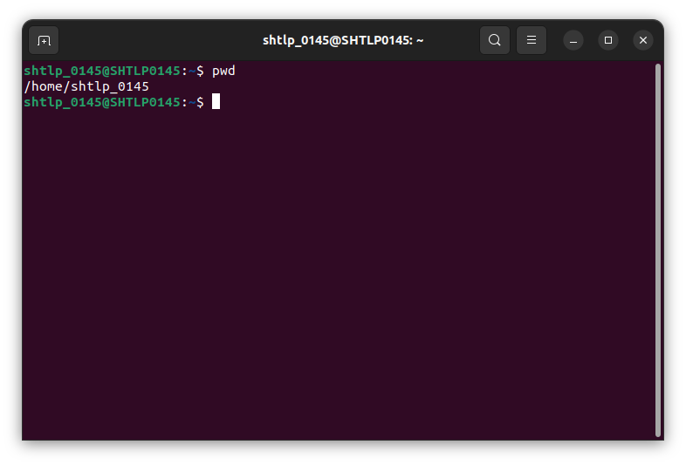
2)ls:

ls : list the content of home directory
ls documents/ : list all the content of document directory
ls / : list all the content of root directory
ls ~ : list the content of home directory
ls .. : means to print out one step back directory structure
ls ../.. : means to go two folder back
ls -l : mean to print content of directory in long format.
ls -a : gives hidden file with all contents
ls -al : give the long list and hidden file
ls -lS : it will sort the directory according to their size (decreasing order)
ls documents/*.html : it will list all the files with extension .html in the document directory.
ls documents/*.* : it will list all the files with all the extensions
ls -lS >out.txt : it will copy the output of ls to a file ie. Out.txt in this case.
ls -d */ : it will list out all the directories.
ls -R: this will show the directory structure
man ls : list all the flags.

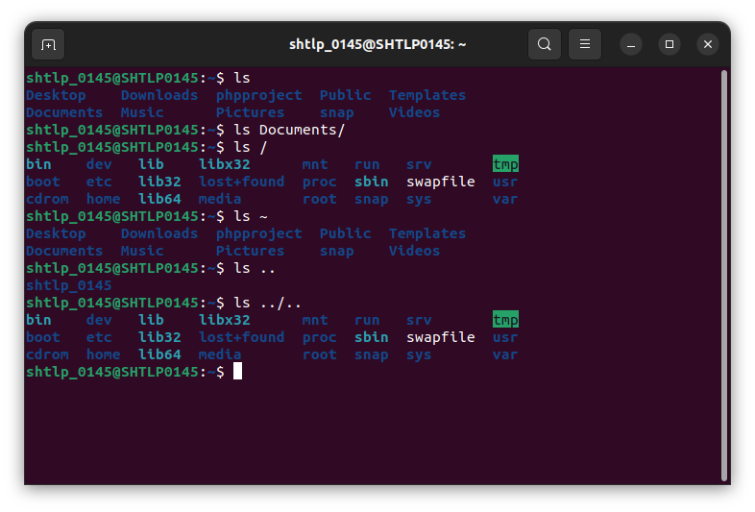

3)clear: scroll and clear down the terminal.

4)cd : change directory

cd / : in the root directory
cd ~ : in the home directory
cd .. : go to parent directory of our current directory
cd documents : go the documents folder

note: if there is a space in a directory name then if we write directory name as it is, it will give error.So, there are 3 methods :
ex: directory name : My Books
cd My\Books
cd “My Books”
cd ‘My Books’

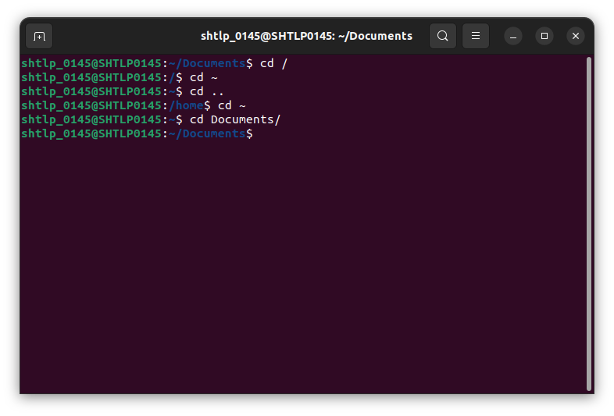
5) cat : displaying texr,combining copies of text,creating new text file.

cat list1.txt : display the content of list1.txt
cat list1.txt list2.txt : display the contents of multiple files( list1 and list2.txt in this example)
cat -b list1.txt : it will display line number to non blank lines.
cat -n list1.txt: it will display line number to all the lines
cat -s list1.txt: it will squeeze all the blank line into one blank line
cat -E list1.txt:it will display dollar sign in the end of each line
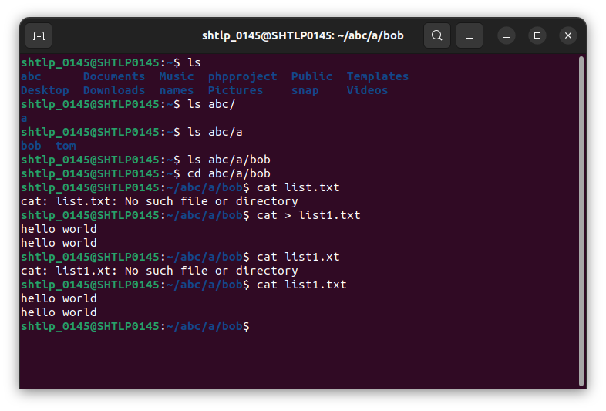

6) redirection: capturing output from a file/command/program and it as a input to other file or program.

Output > file

cat list1.txt list2.txt > out.txt : add the content of list1.txt and list2.txt into out.txt

note: input file is not same as output file.instead append the content of input file into output file.

cat list1.txt list2.txt >list2.txt -> error
cat list1.txt >> list2.txt : this will append the content of list1.txt into list2.txt

ls -al > out.txt : add the output of ls -al into out.txt

7) mkdir: create directory

mkdir image: create directory image.
mkdir image/pics : this will create directory pics inside image directory.

Note: if we give the name of certain directory which is not there to mkdir command then this will give error.use flag for this

mkdir -p names\mark : it will create directory names as well as sub directory mark inside names.

Mkdir -p names/{john,tom ,bob} : this will create multiple directory inside names(this will also be created) directory.
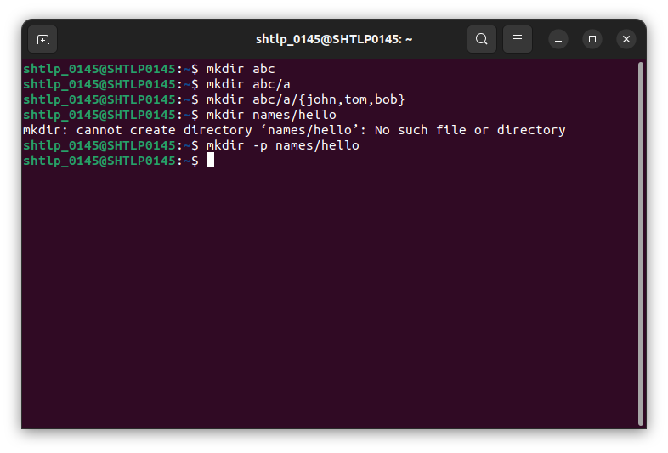

8) rmdir : used to remove the directory or directory structure.

rmdir abc: this will remove directory abc
rmdir a/b/c/d/e: this will remove only the top level directory (ie. e).inorder to remove all the directories ie (a,b,c,d,e) then use -p

rmdir -p a/b/c/d/e : this will remove all the directories ie. a,b,c,d,e

note: verbose -> refers to the mode or setting that displays or gets the extended information

rmdir -pv a/b/c/d/e

note: if any directory contains a file that it cannot delete that directory.it will give error.therefore we can use rm command

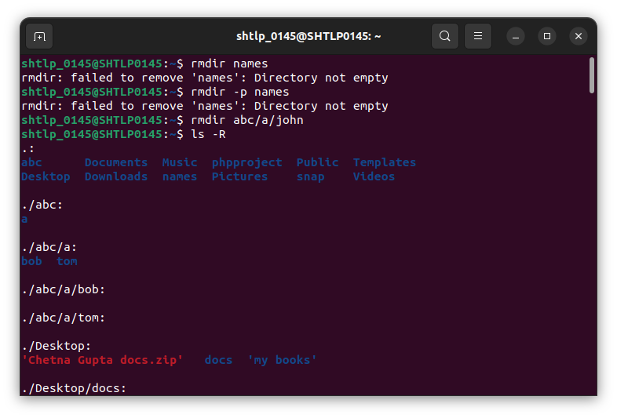

9) rm : remove directory (if it contains the file then also it will work)

